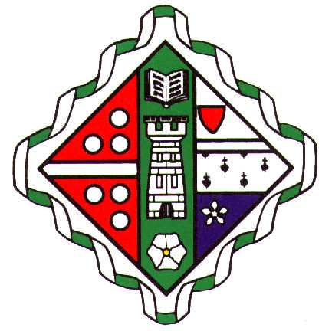
Wellington School
Part-time teacher of Physical Education & Games (0.8 FTE) Maternity Cover

We are looking to appoint a well-qualified and enthusiastic teacher of Physical Education and Games to join this busy and successful department at Wellington School. This maternity cover position becomes available in November/December.

The successful applicant will be required to teach Physical Education and Games to pupils of all ages in this all-through 3 – 18 school. SQA Physical Education is offered at National 5, Higher and Advanced Higher levels and the person appointed will be expected to contribute to the delivery of these certificate courses. A high level of hockey coaching expertise is desirable and all members of the department are required to participate in the programme of weekend fixtures that runs throughout the school year. The post would be suitable for a person new to the profession or a more experienced practitioner.

In addition to the facilities available for sports on the main campus, the school also has its own playing fields, with an all-weather surface and pavilion on the outskirts of Ayr at Doonside.

Wellington School is the only independent school in Ayrshire and the school roll is currently in the region of 500 (Nursery – S6). Year groups in the Senior School typically consist of approximately 50 pupils and most remain in the school until the end of S6. The majority of pupils study 8 National 5 courses in S3/S4, before going on to take 5 Higher courses in S5. Pupils in S6 choose from the wide range of Advanced Higher and Higher courses available and almost all proceed to university. Popular choices of course include Medicine, Dentistry, Veterinary Medicine and Law.

In addition to its curricular provision, Wellington also offers a rich array of other activities and a willingness to participate fully in the life of the school will be expected.

The salary for this post will be in accordance with SNCT scales.

The position is part-time, temporary and is available from November/December.

Applicants must either be registered with GTC Scotland, or eligible for registration. All teaching appointments are subject to clearance through the Disclosure Scotland Protecting Vulnerable Groups Scheme.

Applicants should complete the school’s Job Application Form and provide a covering letter, both of which should be sent by email to vacancies@wellingtonschool.org. A CV is optional and may also be included.

The closing date for applications is Tuesday 5 October.

